Computer Programming  
Lab Tasks



Department of Computer Science - BUIC

Name: Saad Ahmad

Enrollment Number: 01-134222-130

**Exercises/Lab Journal 3**

**Task 1** : Write a C++ program that reads an integer and determines and prints whether it is odd or even using if-else statements.

**Code :**

#include <iostream>

using namespace std;

int main()

{

int a;

cout << "Enter an integer : " << endl;

cin >> a;

/*To check if the entered integer is odd or even

we divide the integer by 2.If the remainder is zero

then the number will be even , and if the remainder

is not zero then the number will be odd0

*/

if (a % 2 == 0)

{

cout << "The entered integer is even" << endl;

}

else

{

cout << "The entered integer is odd" << endl;

}

return 0;

}

**Output:**

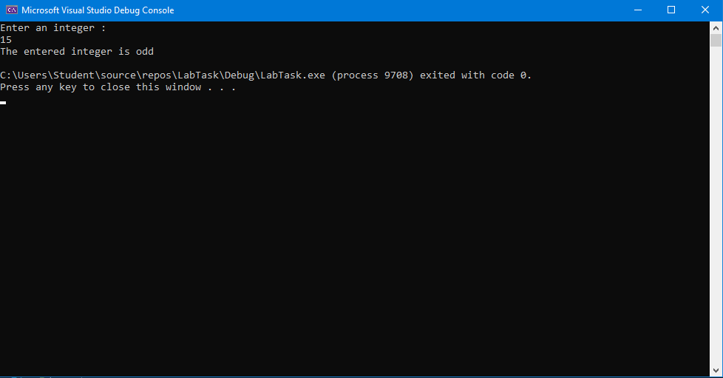

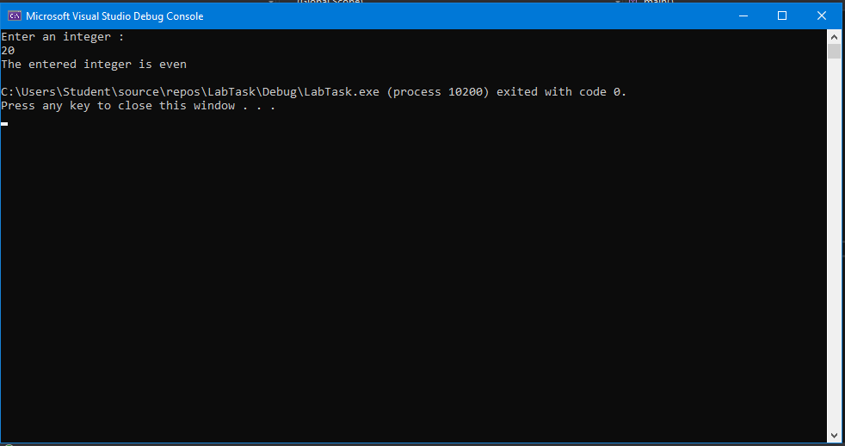

**Task 2 :** Write a program that reads three non zero integers and determines and prints whether they could be the sides of a right angle triangle. (Hint* : Pythagorus Theorem a2 + b2 = c2)

So your program should take three variables a, b and c and check that the sum of square of a and square of b should be equal to the square of c.

**Code :**

#include <iostream>

using namespace std;

int main()

{

int a;

int b;

int c;

jump:

cout << "Enter the base of the triangle : " << endl;

cin >> a;

if (a == 0) {

cout << "You have entered zero." << endl;

goto jump;

}

jump2:

cout << "Enter the perpendicular of the traingle : " << endl;

cin >> b;

if (b == 0) {

cout << "You have entered zero." << endl;

goto jump2;

}

jump3:

cout << "Enter the hypotenuse of the triangle : " << endl;

cin >> c;

if (c == 0) {

cout << "You have entered zero." << endl;

goto jump3;

}

if (a * a + b * b == c * c)

{

cout << "Your triangle is a right angled triangle." << endl;

}

else

{

cout << "Your triangle is not a right angled triangle." << endl;

}

return 0;

}

**Output:**

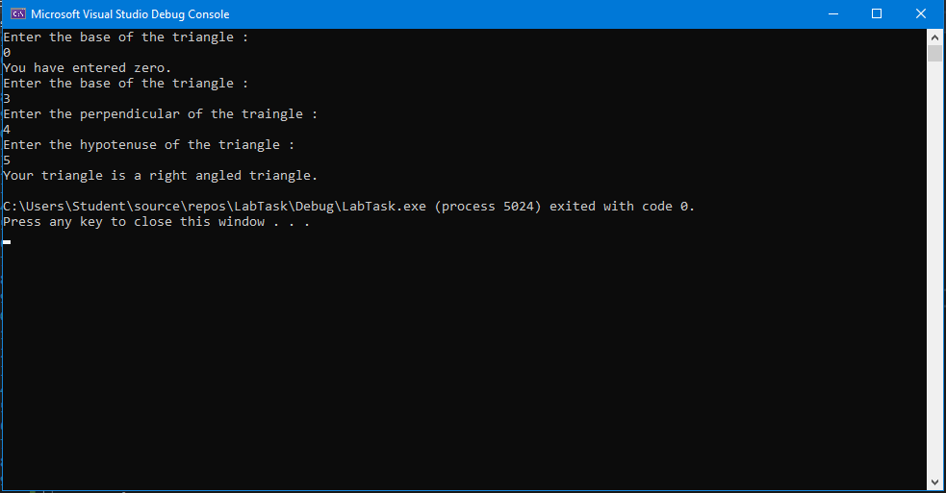

**Task3:** Write a program for a basic calculator. Your calculator should take two integers. Then it should display options for different operations and then ask the user for choice. Based on user’s choice it will perform the operation. The options will be displayed as following

* + - * + **Press 1 for addition**
        + **Press 2 for subtraction**
        + **Press 3 for multiplication**
        + **Press 4 for division**
        + **Press 5 for finding the remainder**

**Code:**

#include <iostream>

//This preprocessor directive contains the CLS command which is used to clear the console after the program has finished.

#include <stdlib.h>

using namespace std;

int main()

{

jump:

int num1;

int num2;

int a;

cout << "Enter number 1 : " << endl;

cin >> num1;

cout << "Enter number 2 : " << endl;

cin >> num2;

cout << "Press 1 for addition" << endl;

cout << "Press 2 for subtraction" << endl;

cout << "Press 3 for multiplication" << endl;

cout << "Press 4 for division" << endl;

cout << "Press 5 for finding the remainder" << endl;

cin >> a;

switch (a)

{

case 1:

cout << num1 + num2 << endl;

break;

case 2:

cout << num1 - num2 << endl;

break;

case 3:

cout << num1 * num2 << endl;

break;

case 4:

cout << num1 / num2 << endl;

break;

case 5:

cout << num1 % num2 << endl;

break;

default:

cout << "You have entered an invalid number" << endl;

}

//pause is used so that the result is not cleared instantly.

system("pause");

//CLS is used to clear the console after the programme has completed.

system("CLS");

goto jump;

return 0;

}

**Output:**

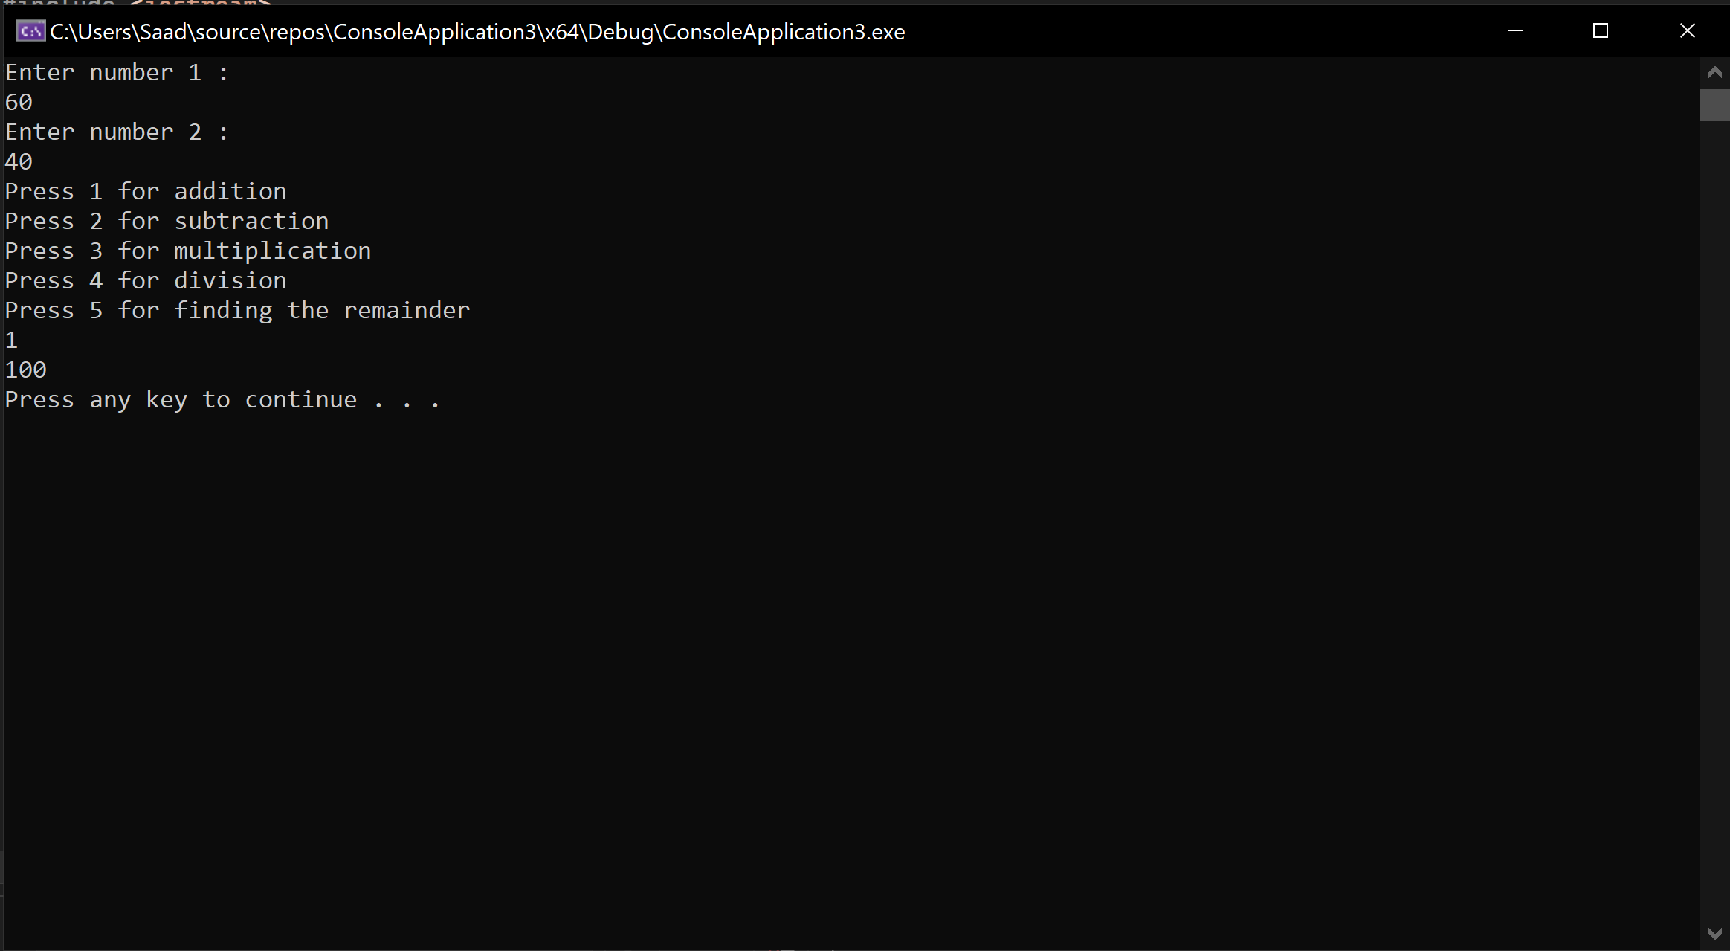

**Task 4 :** Write a C++ program (use if-else statement) to compute the telephone bill for the city consumers. The bill computed according to the number of calls.

* If numbers of calls are less than and equal to 100, then the rate per call is rs.0.80 and the meter charges is Rs. 250.
* If numbers of calls are greater than 100, then the rate per call is computed is Rs. 1.00 and the meter charges are minimum Rs.350.
* **Formula for bill calculation is:**

**Phone Bill = meter charges + (number of calls x rate per call)**

**Code:**

#include <iostream>

using namespace std;

int main()

{

float phonebill;

int calls;

int metercharge;

float rate;

jump :

cout << "Enter the number of calls" << endl;

cin >> calls;

if (calls <= 0)

{

cout << "You have entered invalid number of calls" << endl;

goto jump;

}

if (calls <= 100)

{

rate = 0.80;

metercharge = 250;

}

else if (calls > 100)

{

rate = 1.00;

metercharge = 350;

}

phonebill = metercharge + (calls * rate);

cout << "Your phonebill is Rs." << phonebill << endl;

return 0;

}

**Output:**



